Strengths-Based Personal Statements
There are four elements to personal branding: Authenticity, Values, Natural Abilities and Skills (Strengths) and Consistency. The reflection below will walk you through writing a complete strengths-based personal statement.

Telling Your Story
Your story is what others think of you when your picture or your name comes up. It communicates the talents and values you and your company represent.

Story Reflection #1:
Think of a brand you respect. List some words and feelings you associate with that brand:

Story Reflection #2:
Think of a person you respect. How do they represent themselves and their values?

Story Reflection #3:
What are some important parts of your story that have impacted who you are and your motivations, your values and your perspectives?

Understanding Your Why
Understanding our why can help us create a more impactful personal statement.

List three times when you were at your best:
1)

2)

3)

What is the impact you want to have on the world around you?

What is the change you want to create?

What problem can you help solve for a potential employer or society?

How do each of your strengths show up in your why?
1)
2)
3)
4)
5)
Consider Your Values
Values are the things we cherish most in life. They help shape our priorities and our identity. (Values Activity adapted from therapistaid.com)

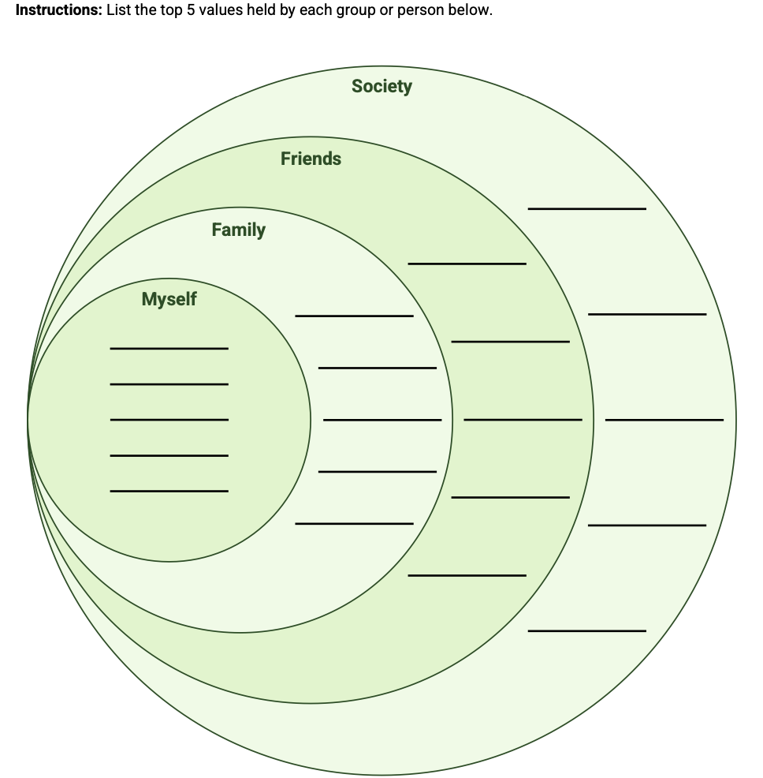
Words and Phrases
List some words/phrases that really resonate with you from each strength from your or your Insights Report.

Strength 1: ________________________
Words and Phrases That Resonate:

Strength 2: ________________________
Words and Phrases That Resonate:

Strength 3: ________________________
Words and Phrases That Resonate:

Strength 4: ________________________
Words and Phrases That Resonate:

Strength 5: ________________________
Words and Phrases That Resonate:

Goals
Remember as our goals change and we are exposed to new opportunities and experiences, our personal statement might also change. Each time you revisit it, it’s important to consider your goals. Keep your WHY and values you’ve identified in mind as you write your goals.

What’s a goal you have for yourself personally or professionally in the next 1 to 3 years?

If you prefer to think of big goals, where would you like to be in 10 years?

How can you use your top five strengths to achieve these goals?

Writing Your Personal Statement
Now that you’ve dug deeper into each of the four elements of a personal statement, it’s time to start putting it together. Start by considering your why and then weave your strengths-based language and your personal story throughout. Adding strengths-based language can change your personal statement from “hard-working and detail-oriented” to “Motivated to positively impact mental health and create lasting change for children through the arts.”

Your Personal Statement:

